#Number of male and female employee

Explanation

* Utilized the table function to display the total number of male and female

Output

Explanation

* There are a total of 25898 female employees and 23755 male employees

# Gender ratio

Explanation

* Using the data collected from total number of male and female employees, I have created a 3d piechart from plotrix package.

Output

Explanation

* From this chart, female employees occupies 52.16% and male employees occupies 47.84%. As a result, there is more female employee than male employee

# The number of active male and female employees

Explanation

* Firstly, I collect the data of both male and female employees with active working status.
* After that, I created a horizontal barplot with data collected

Output

Explanation

* From the chart above, we can conclude that there are more active female employees than male employees.

# The number of terminated male and female employees

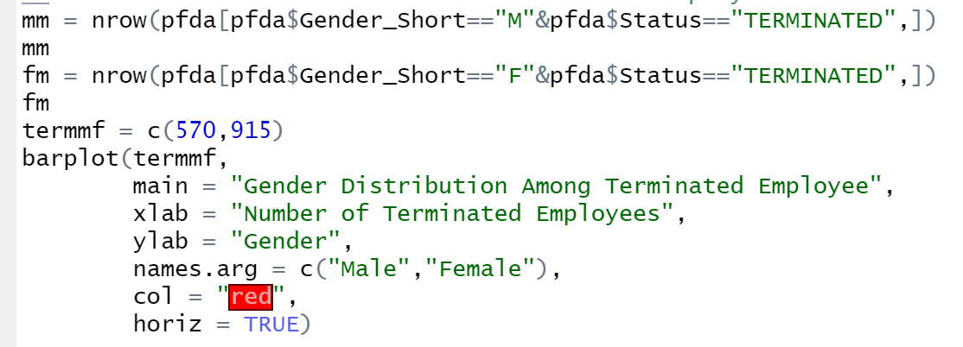

Explanation

* Firstly, I collect the data of both male and female employees with terminated working status.
* After that, I created a horizontal barplot with data collected

Output

Explanation

* From this chart, we can conclude that there are more female employees being terminated compared to male employees

# Male and female voluntarily retirement rate

Explanation

* Get the number of male and female voluntarily retire count
* Find the rate and round it up to decimal point if there is any

Output

Explanation

* We can tell that there are 468 male employees voluntarily retired and that occupies 37% of the overall workforce. On the other hand, there are 802 female employees voluntarily retired and they share the remaining 63%.

# Male and female involuntarily retirement rate

Explanation

* Get the number of male and female involuntarily retire count
* Find the rate and round it up to decimal point if there is any

Output

Explanation

* We can tell that there are 102 male employees involuntarily retired and that occupies 47% of the overall workforce. On the other hand, there are 113 female employees involuntarily retired and they share the remaining 53%.

# Termination count of female employee per year

Explanation

* Get all the existing age group and the number of termination of every age group
* Create a line graph to show the output

Output

Explanation

* We can observe that age 65 has the highest termination count followed by age of 30.

# Number of active females

Explanation

* Get all the existing age group and the number of employees that are still active of every age group
* Create a bar chart to show the output

Output

Explanation

* The highest number of female employees that are still active are at the age of 50. The remaining are roughly the same except for low number of active female employee at the age of 19 and 65

# What factor contributes to female termination count

Explanation

* Identify the reason leading to female termination
* Create a horizontal barchart with data collected

Output



Explanation

* We can tell that the most common reason is retirement with 591 employees, followed by resignation with 211 employees and lastly layoff with 113 employees

# What are the reason for termination for age 30 female

Explanation

* Get all the termination reason from female employee aged 30
* Create a piechart showing percentage of each reason

Output

Explanation

* From this chart, we can conclude that resignation shares the highest percentage followed by layoff.

# What is the reason for termination for age 65 female

Explanation

* Identify the termination reason from female employee aged 30
* Create a horizontal barplot to display the result

Output

Explanation

- Based on this graph, we can deduce that the only reason for a 65-year-old female employee's termination is retirement.

# Termination count of male employee per year

Explanation

* Get all the existing age group and the number of terminations of every age group
* Create a line graph to show the output

Output

Explanation

* We can observe that age 60 has the highest termination count followed by age of 21.

# Number of active males in existing age group

Explanation

* Get all the existing age group and the number of employees that are still active of every age group
* Create a bar chart to show the output

Output

Explanation

* The highest number of male employees that are still active are at the age of 27. The remaining are roughly the same except for low number of active male employee at the age of 19 to 24 and after 60 years old

# What factor contributes to male termination count

Explanation

* Identify the reason leading to female termination
* Create a horizontal barplot with data collected

Output



Explanation

* We can tell that the most common reason is retirement with 294 employees, followed by resignation with 174 employees and lastly layoff with 102 employees

# What are the reason for termination for age 21 Male

Explanation

Output

Explanation

* From this chart, we can conclude that resignation shares the highest percentage followed by layoff.

# What are the reason for termination for age 60 Male

Explanation

* Identify the termination reason from male employee aged 60
* Create a horizontal barplot to display the result

Output

Explanation

* Based on this graph, we can deduce that the only reason for a 60-year-old male employee's termination is retirement.

Justification

Overall, there are more female employees compared to male employees. The most frequent causes of termination for both male and female employees are retirement, resignation, and layoff. In terms voluntary and involuntary retirement rate, female employees share the higher percentage in both field in comparison to male employees. The most female employees have been terminated at age 65, followed by age 30. Retirement is the sole factor in the termination of 65-year-old female employees. For female employees who are 30 years old, the main causes are resignation and sparse layoffs. On the other hand, male employees between the ages of 21 and 60 had the highest number of terminations. The primary cause of the 60-year-old male employees' termination was retirement. For male employees in the age of 21, resignation is the primary cause, followed by a small number of layoffs. High number of retirements for male aged 60 and female aged 65 indicate that it is time for them to take a break from their demanding working lives or that they simply want to take it easy and enjoy life.

Female employees who left their jobs around the age of 30 may choose to begin a new career in a different industry for a variety of reasons, such as discovering a new passion or not liking their current working environment. However, those who were laid off at the age of 30 might indicate that their level of productivity falls short of what is required in the workplace. Male employees who quit their jobs at age 21 may be considering starting their own businesses or looking into alternative career paths given their youth. Male workers who were laid off at age 21 may have bad work ethic, such as immaturity that results in low production or even poor time management that causes them to be consistently late to work.